**YEMEN CRISES**

Civil wars across a nation are always a curse for its citizens and the nation’s peace. Since March 2015, Yemen is the giant predicament across the whole of the planet. The crisis started with the Houthis, a Zaidi Shiite movement overthrowing the Yemen government as led by Saudi Arabia.

Extracted from the surveys, a few spine-chilling statistics have been released displaying the petrifying situation of Yemen.

* 24 million people, that is about 80% of the national population is in need of some serious assistance and help.
* About 12 million children require assistance with 10.2 million lacking even in the basic healthcare facilities.
* 7.8 million Children lack educational facilities and 2.4 million under 5 children are malnourished.
* The UN verified 7,700 number of civilian deaths as of March 2020.

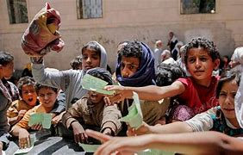

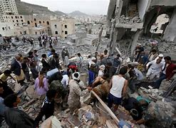

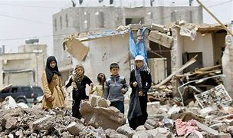

Horrifying, right? Well, this exactly is the situation of most Yemen citizens with the lack of access to various daily needs and requirements.

This Civil war led to the extension of various medical issues, diseases, loss of houses for the citizens, displacement of lives from their homes, and a threat to pandemic and famine. With these impacts, this crisis has been “the worst in the world” as stated by the UN.

With the Covid-19 pandemic, a crisis over another crisis led an evil eye on the Yemen citizens. This crisis over the crisis is beating its citizens in extreme ways.

**The journey leading to the present crisis**

The military conflict and the civil war are born from a serious of ongoing political divisions.

* **Subsidy Backlash:** From the international monetary fund, $550 million of the loan was accounted for the economic reforms, and with the growing pressure, the Hadi’s government lifted the fuel prices in July 2014. The Houthi movement protested against the growing prices and a demand for a new government.
* **Houthi takeover:** Houthis captured the prominent parts of Sanaa by September 2014 breaking the UN peace deal and thus moving southwards. With the growing pressure, the Hadi’s government resigned in January 2015 with Hadi fleeing off to Saudi Arabia.
* **Military division:** Saleh’s loyal militants aligned with Houthis increasing their success. Other ones who were loyal to the Hadi government aligned with the remaining militants.
* **Saudi intervention:** 2015, then marked with Hadi in exile, and Riyadh launching the military campaign starting with the air force fights for the restoration of the Hadi government swiping away the Houthis.

All of these created the situation for the civil war across the country premises with local citizens suffering due to the political issues and divisions. In 2019, the UN stated how the citizens’ sufferings have been unprecedented and the chilling situation had made their lives miserable.